**PROJECT REPORT**

**On**

1. **LEARNING WEBSITE**



**Bachelor of Technology**

**In**

**Computer Science & Engineering**

**Chandigarh Group of Colleges, Mohali**

Submitted To: Submitted By:

Ms. Shafi Jasuja Vinay Kumar

1802899

CSE-V2

Department of CSE CEC,LANDRAN

**ABSTRACT**

In our project we propose a method to help students to prepare for their campus placements or to learn new Trending Technologies which are in demand. It is Web based Project which makes use of different Technologies.

Website contains different sections for different Technologies such as Interview Questions, Programming Languages, Block Chain etc. The best thing about Website is that it provides all the content for free and contains videos for each topic.

* A Multiple Pager Website is created using HTML5 and CSS3 with different elements to show information. JavaScript is used to add Dynamic view to the Website .The main Objective of this Project is to provide best resources which are available free at One Platform.
* Programming Languages section includes languages like Java, C++, Python, JavaScript etc. There are separate sections for those who want to prepare or learn Android Development and Web Development.
* Website provides a complete Road Map to students to learn Technologies and Implement them.

After learning Technology their is need to practice it, so here comes the Website with another feature which includes Project Section . Project Section includes various projects on Android Development, Web Development, Data Science ,Machine learning etc.

**Keywords-** HTML5; Buttons; Div Container; recursive Backtracking algorithm,time complexities,Web-based E-Learning Website; JavaScript,Android Development,Web Development,Data Science, Machine Learning, Artificial Intelligence, Block Chain etc..

**Introduction**

A learning system based on formalized teaching but with the help of electronic resources is known as E-learning. While teaching can be based in or out of the classrooms, the use of computers and the Internet forms the major component of E-learning. E-learning can also be termed as a network enabled transfer of skills and knowledge, and the delivery of education is made to a large number of recipients at the same or different times.

  
  
  
E-learning has proved to be the best means in the corporate sector, especially when training programs are conducted by MNCs for professionals across the globe and employees are able to acquire important skills while sitting in a board room, or by having seminars, which are conducted for employees of the same or the different organizations under one roof.

**Problem Statement & Objectives**

Traditional System of learning is the oldest form of delivering education to students through face to face interaction between teachers and students. The schools are divided into grades which include both primary and secondary education system.

Although this type of education system is practiced all over the world it is losing its popularity nowadays. Everything nowadays is part of the digital revolution, education is no exception.

The traditional education system needs to be revised in order to continue delivering education successfully in the present scenario which we called the digitized world.

The traditional education system is well–organized institution with proper classroom, building and teacher faculties. Everything that is going to be taught is pre-planned not only regular activities but also extracurricular activities.

**Objectives**

E-Learning is a learning process with the combination of content that is both delivered digitally and through face-to-face learning. eLearning contributes to the shifts from traditional face-to-face learning to the use of web technological tools which enhances collaborative learning and presents an entirely new learning platform for students.

* Enhance the quality of learning and teaching.
* Meet the learning style or needs of students.
* Improve the efficiency and effectiveness.
* Improve user-accessibility and time flexibility to engage learners in the learning process.

E-Learning is vast and an expanding platform with huge prospective in higher education. Since there are many challenges in making eLearning effective, it is important to know how to manage it and access to the resources.

Take a minute and just imagine if one is not having the roadmap to guide from start to finish is actually like plunging into eLearning without an effective strategy because learners would be lost in the learning content.

**E Learning Website**

**Summary**

Web-based learning is commonly referred to as eLearning or online learning. It essentially includes learning online through the courses that are offered on the net. Emails, live lectures, and videoconferencing are all possible through the net. This enables all the participants to give their views on a particular topic and then discuss them further. They also offer static pages like course materials that are printed for the benefit of all the participants.

**Advantages**

* You are able to link the various resources in several varying formats.
* It is a very efficient way of delivering courses online.
* Due to its convenience and flexibility, the resources are available from anywhere and at any time.
* Everyone, who are part time students or are working full time, can take advantage of web-based learning.
* As you have access to the net 24x7, you can train yourself anytime and from anywhere also.
* It is a very convenient and flexible option; above all, you don't have to depend on anyone for anything.

**Disadvantages**

* Most of the online assessments are limited to questions that are only objective in nature.
* There is also the problem of the extent of security of online learning programs.
* The authenticity of a particular student's work is also a problem as online just about anyone can do a project rather than the actual student itself.

**TECHNOLOGY USED**

* Operating System 64 Bit(Windows,Mac,Linux etc).
* **HTML5:** It is used to provide structure to the Website.Different buttons are created using HTML5 elements and images ,texts are also used to make it more understandable.
* **CSS3:** CSS3 is used to provide Website a cool look so Whenever someone come to website to play Sudoku solver the person not get bored. CSS3 various properties and selectors are used to make Website Interactive.
* **JavaScript:** JavaScript is used to write the logic behind the Sudoku Solver. The Algorithm is written in JavaScript which performs all operations. JavaScript Interact with HTML5 elements to perform different operations on the elements.
* **Visual Studio Code:** Visual Studio Code is the most used Code Editor for Web Development related work. It provides different Extensions to make work easier and auto complete option to make writing code in easier way.
* **Google Fonts:** Google fonts are used to provide interactive fonts to the text or Numbers which appear on the container containing different buttons.
* **Responsive Design:** In order to make the website work efficiently on Mobile Phones,Tablets and Laptops it must be Responsive in nature.
* **Web Browser:** In order to run the Sudoku solver built by using Web Technologies we must need a latest browser which support Web Technologies.

**Source Code With Working Images**

**HTML5**

<!DOCTYPE html>

<html>

<head>

<link rel="shortcut icon" type="png" href="/icon/favicon.png">

<meta charset="utf-8">

<meta http-equiv="X-UA-Comaptible" content="IE=edge">

<title>LearnEd</title>

<meta name="desciption" content="">

<meta name="viewport" content="width=device-width, initial-scale=1">

<link rel="stylesheet" type="text/css" href="style.css">

<script type="text/javascript" src="script.js"></script>

<script src="https://code.jquery.com/jquery-3.2.1.js"></script>

<script>

$(window).on('scroll', function() {

if ($(window).scrollTop()) {

$('nav').addClass('black');

} else {

$('nav').removeClass('black');

}

})

</script>

</head>

<body>

<!-- Navigation Bar -->

<header id="header">

<nav>

<div class="logo"><img src="/icon/logo.png" alt="logo"></div>

<ul>

<li><a class="active" href="">Home</a></li>

<li><a href="#portfolio_section">Portfolio</a></li>

<li><a href="#team_section">Team</a></li>

<li><a href="#services_section">Courses</a></li>

<li><a href="#contactus_section">Contact</a></li>

</ul>

<div class="srch"><input type="text" class="search" placeholder="Search here..."><img src="/icon/search.png" alt="search" onclick=slide()></div>

<a class="get-started" href="login.html">Get Started</a>

<img src="/icon/menu.png" class="menu" onclick="sideMenu(0)" alt="menu">

</nav>

<div class="head-container">

<div class="quote">

<p>The beautiful thing about learning is that nobody can take it away from you</p>

<h5>Education is the process of facilitating learning, or the acquisition of knowledge, skills, values, beliefs, and habits. Educational methods include teaching, training, storytelling, discussion and directed research!</h5>

<div class="play">

<img src="/icon/play.png" alt="play"><span><a href="#services_section" target="_blank">Watch Now</a></span>

</div>

</div>

<div class="svg-image">

<img src="/extra/svg1.jpg" alt="svg">

</div>

</div>

<div class="side-menu" id="side-menu">

<div class="close" onclick="sideMenu(1)"><img src="/icon/close.png" alt=""></div>

<div class="user">

<img src="creator/Profile.jpg" alt="Username">

<p>Vinay Kumar</p>

</div>

<ul>

<li><a href="#about_section">About</a></li>

<li><a href="#portfolio_section">Portfolio</a></li>

<li><a href="#team_section">Team</a></li>

<li><a href="#services_section">Services</a></li>

<li><a href="#contactus_section">Contact</a></li>

<li><a href="#feedBACK">Feedback</a></li>

</ul>

</div>

</header>

<!-- Some Popular Subjects -->

<div class="title">

<span>Popular Subjects on LearnEd</span>

</div>

<br><br>

<div class="course">

<center>

<div class="cbox">

<div class="det">

<a href="subjects/Machine.html"><img src="images/courses/book.png">Machine Learning</a>

</div>

<div class="det">

<a href="subjects/Android.html"><img src="images/courses/d1.png">Android Development</a>

</div>

<div class="det">

<a href="subjects/CodingLang.html"><img src="images/courses/paper.png">Coding Languages</a>

</div>

<div class="det">

<a href="subjects/web.html"><img src="images/courses/d1.png">Web Development</a>

</div>

</div>

</center>

<div class="cbox">

<div class="det">

<a href="subjects/DigitalMarketing.html"><img src="images/courses/computer.png">Digital Marketing</a>

</div>

<div class="det">

<a href="subjects/DataStructures.html"><img src="images/courses/data.png">Data Structures</a>

</div>

<div class="det">

<a href="subjects/Algorithms.html"><img src="images/courses/algo.png">Algorithms</a>

</div>

<div class="det det-last">

<a href="subjects/Projects.html"><img src="images/courses/projects.png">Projects</a>

</div>

</div>

</div>

</body>

</html>

HTML Code Link:

<https://github.com/VinayKumar1512/ELearningWebsite/blob/master/index.html>

<https://github.com/VinayKumar1512/ELearningWebsite/blob/master/login.html>

**CSS3**

@import url('https://fonts.googleapis.com/css?family=Montserrat:500&display=swap');

@import url('https://fonts.googleapis.com/css?family=Dancing+Script&display=swap');

@import url('https://fonts.googleapis.com/css?family=Open+Sans&display=swap');

@import url('https://fonts.googleapis.com/css2?family=Baloo+Bhaina+2:wght@500&display=swap');

@import url('https://fonts.googleapis.com/css2?family=Baloo+Bhai+2:wght@700&display=swap');

* {

box-sizing: border-box;

margin: 0;

padding: 0;

}

html {

scroll-behavior: smooth;

}

body {

background: #FFF;

font-family: 'Baloo Bhai 2', cursive;

}

/**************Nav bar and Heading Section*********************/

header {

height: 100vh;

}

.black {

box-shadow: 0 2px 10px rgba(0, 0, 0, 0.5);

}

nav {

padding-top: 20px;

padding-bottom: 20px;

top: 0;

position: fixed;

display: flex;

width: 100%;

z-index: 1000;

background: white;

justify-content: space-around;

transition: 1.5s;

align-items: center;

}

nav ul {

display: flex;

align-items: center;

}

nav ul li {

list-style: none;

margin: 5px 10px;

}

nav ul li a {

padding: 2px 10px;

color: #2e2e2e;

cursor: pointer;

transition: .5s;

text-decoration: none;

font-family: 'Baloo Bhai 2', cursive;

font-size: 22px;

}

nav ul li a:hover {

color: #fff;

background: #DF2771;

border-radius: 50px;

}

.active {

color: #fff;

border-radius: 5px;

background: #DF2771;

border-radius: 50px;

}

.srch {

padding: 2px 10px;

display: flex;

/* align-items: center; */

justify-content: center;

/* background: #0066ff; */

border: 1px solid;

border-radius: 20px;

}

.srch img {

width: 25px;

cursor: pointer;

}

.srch .search {

/* padding: 2px 10px; */

outline: none;

border: none;

background: transparent;

}

.get-started {

margin-left: 50px;

padding: 5px 20px;

border: 2px solid #DF2771;

border-radius: 20px;

text-decoration: none;

transition: .5s;

background-color: #DF2771;

color: #fff;

}

.get-started:hover {

color: #2e2e2e;

background: #fff;

}

.logo img {

width: 120px;

cursor: pointer;

transition: all 1s;

}

a,

button {

float: left;

font-family: 'Baloo Bhai 2', cursive;

font-weight: 500;

font-size: 15px;

color: #2E3D49;

display: block;

text-decoration: none;

text-align: center;

}

.head-container {

margin-top: 245px;

display: flex;

flex-wrap: wrap;

align-items: center;

justify-content: space-around;

}

.quote {

width: 600px;

transform: translateY(-50px);

}

.quote h5 {

margin-top: 20px;

color: #0009;

line-height: 20px;

text-shadow: 4px 4px 2px rgba(155, 236, 241, 0.8);

}

.quote p {

font-size: 50px;

color: #2e2e2e;

text-shadow: 4px 4px 2px rgba(155, 236, 241, 0.8);

}

.quote .play {

margin-top: 20px;

display: flex;

/* justify-content: center; */

align-items: center;

}

.quote .play img {

width: 45px;

cursor: pointer;

filter: drop-shadow(0 0 10px #0002);

}

.quote .play span a {

margin-left: 10px;

font-size: 20px;

font-weight: 900;

color: rgba(0, 0, 0, 0.8);

cursor: pointer;

}

.svg-image img {

width: 500px;

filter: drop-shadow(0 20px 10px rgba(0, 0, 0, 0.2));

}

/*****************Above section is of navabar and Heading***********/

/* SIDE MENU */

.menu {

cursor: pointer;

width: 25px;

display: none;

}

.side-menu {

width: 100%;

height: 100%;

background: rgba(182, 33, 90, 0.993);

position: absolute;

top: 0;

transition: .8s;

z-index: 2000;

transform: translateX(-100%);

}

.side-menu ul {

margin-top: 35%;

display: flex;

flex-direction: column;

justify-content: center;

/* background: #FA4B37; */

}

.side-menu ul li {

list-style: none;

/* background: #009900; */

display: flex;

justify-content: center;

align-items: center;

/* border-bottom: 1px solid #fff; */

/* padding: 10px 0px; */

}

.side-menu ul li:hover a {

background: #fff;

color: #DF2771;

}

.side-menu ul li a {

color: #FFF;

width: 100%;

font-size: 1em;

/* background: #2E3D49; */

text-decoration: none;

padding: 15px 0px;

}

.close img {

float: right;

width: 35px;

cursor: pointer;

margin: 10px;

}

.user {

display: flex;

justify-content: center;

align-items: center;

margin-top: 10%;

}

.user img {

width: 60px;

border-radius: 50%;

border: 2px solid #fff;

filter: drop-shadow(0 10px 20px #0004);

margin-right: 30px;

cursor: pointer;

}

.user p {

color: #fff;

cursor: pointer;

}

.user img,

.user p {

opacity: 1;

}

/*Common things in all sections*/

#about_section,

#portfolio_section,

#team_section,

#services_section,

#contactus_section {

font-family: 'Baloo Bhai 2', cursive;

color: #2E3D49;

position: relative;

}

.diffSection {

width: 100%;

/*position: relative;*/

justify-content: center;

align-items: center;

}

.diffSection .content {

margin: 10px;

text-align: center;

padding: 10px 100px;

font-size: 1.1em;

}

/*PORTFOLIO Section*/

.extra {

width: 100%;

}

.extra p {

padding: 30px;

padding-bottom: 150px;

font-size: 50px;

text-align: center;

color: black;

background-image: linear-gradient(rgba(0, 0, 0, 0), rgba(0, 0, 0, 0.7)), url("images/extra/b1.jpg");

background-size: cover;

background-attachment: fixed;

z-index: -9;

font-family: 'Baloo Bhai 2', cursive;

}

.smbox {

display: flex;

flex-wrap: wrap;

transform: translateY(-100px);

justify-content: center;

}

.smbox .data:hover {

color: black;

}

.smbox span {

margin: 1%;

background: #fff;

box-shadow: inset 0px 0px 25px rgba(0, 0, 0, 0.2), 0 0 40px rgba(0, 0, 0, 0.3);

border-radius: 50px;

padding: 30px 50px;

cursor: pointer;

}

.smbox span:hover {

transform: scale(1.3);

transition: .5s ease;

background-color: #f7b42c;

background-image: linear-gradient(315deg, #f7b42c 0%, #fc575e 74%);

}

.smbox .data {

font-size: 80px;

color: #FA6146;

}

.smbox .det {

font-size: 20px;

color: #272529;

font-family: 'Baloo Bhaina 2', cursive;

}

/*Title Section*/

.title {

/* margin-top: 160px; */

font-family: 'Baloo Bhai 2', cursive;

font-size: 30px;

text-align: center;

color: #2E3D49;

}

CSS Code Link:

<https://github.com/VinayKumar1512/ELearningWebsite/blob/master/style.css>

<https://github.com/VinayKumar1512/ELearningWebsite/blob/master/loginStyle.css>

**Javascript:**

// Changing the style of scroll bar

// window.onscroll = function() {myFunction()};

// function myFunction() {

// var winScroll = document.body.scrollTop || document.documentElement.scrollTop;

// var height = document.documentElement.scrollHeight - document.documentElement.clientHeight;

// var scrolled = (winScroll / height) * 100;

// document.getElementById("myBar").style.width = scrolled + "%";

// }

function scrollAppear() {

var introText = document.querySelector('.side-text');

var sideImage = document.querySelector('.sideImage');

var introPosition = introText.getBoundingClientRect().top;

var imagePosition = sideImage.getBoundingClientRect().top;

var screenPosition = window.innerHeight / 1.2;

if (introPosition < screenPosition) {

introText.classList.add('side-text-appear');

}

if (imagePosition < screenPosition) {

sideImage.classList.add('sideImage-appear');

}

}

window.addEventListener('scroll', scrollAppear);

// For switching between navigation menus in mobile mode

var i = 2;

function switchTAB() {

var x = document.getElementById("list-switch");

if (i % 2 == 0) {

document.getElementById("list-switch").style = "display: grid; height: 50vh; margin-left: 5%;";

document.getElementById("search-switch").style = "display: block; margin-left: 5%;";

i++;

} else {

document.getElementById("list-switch").style = "display: none;";

document.getElementById("search-switch").style = "display: none;";

i++;

}

}

// For LOGIN

var x = document.getElementById("login");

var y = document.getElementById("register");

var z = document.getElementById("btn");

var a = document.getElementById("log");

var b = document.getElementById("reg");

var w = document.getElementById("other");

function register() {

x.style.left = "-400px";

y.style.left = "50px";

z.style.left = "110px";

w.style.visibility = "hidden";

b.style.color = "#fff";

a.style.color = "#000";

}

function login() {

x.style.left = "50px";

y.style.left = "450px";

z.style.left = "0px";

w.style.visibility = "visible";

a.style.color = "#fff";

b.style.color = "#000";

}

// CheckBox Function

function goFurther() {

if (document.getElementById("chkAgree").checked == true) {

document.getElementById('btnSubmit').style = 'background: linear-gradient(to right, #FA4B37, #DF2771);';

} else {

document.getElementById('btnSubmit').style = 'background: lightgray;';

}

}

function google() {

window.location.assign("https://accounts.google.com/signin/v2/identifier?service=accountsettings&continue=https%3A%2F%2Fmyaccount.google.com%2F%3Futm_source%3Dsign_in_no_continue&csig=AF-SEnbZHbi77CbAiuHE%3A1585466693&flowName=GlifWebSignIn&flowEntry=AddSession", "_blank");

}

function searchdisplay() {

document.getElementById('searchpanel').style.display = "block";

}

function display(n) {

var img1 = document.getElementById('img1');

var img2 = document.getElementById('img2');

var img3 = document.getElementById('img3');

var img4 = document.getElementById('img4');

var s1 = document.getElementById('s1');

var s2 = document.getElementById('s2');

var s3 = document.getElementById('s3');

var s4 = document.getElementById('s4');

img1.style = 'display: none;';

img2.style = 'display: none;';

img3.style = 'display: none;';

img4.style = 'display: none;';

s1.style = 'background: #DF2771; color: #FFF;';

s2.style = 'background: #DF2771; color: #FFF;';

s3.style = 'background: #DF2771; color: #FFF;';

s4.style = 'background: #DF2771; color: #FFF;';

if (n == 1) {

img1.style = 'display: block;';

s1.style = 'background: #E5E8EF; color: #DF2771;';

}

if (n == 2) {

img2.style = 'display: block;';

s2.style = 'background: #E5E8EF; color: #DF2771;';

}

if (n == 3) {

img3.style = 'display: block;';

s3.style = 'background: #E5E8EF; color: #DF2771;';

}

if (n == 4) {

img4.style = 'display: block;';

s4.style = 'background: #E5E8EF; color: #DF2771;';

}

}

function sideMenu(side) {

var menu = document.getElementById('side-menu');

if (side == 0) {

menu.style = 'transform: translateX(0vh); position:fixed;';

side++;

} else {

menu.style = 'transform: translateX(-100%);';

side++;

}

}

JavaScript Code Link:

<https://github.com/VinayKumar1512/ELearningWebsite/blob/master/script.js>

**Check Full Project at: <https://github.com/VinayKumar1512/ELearningWebsite>**

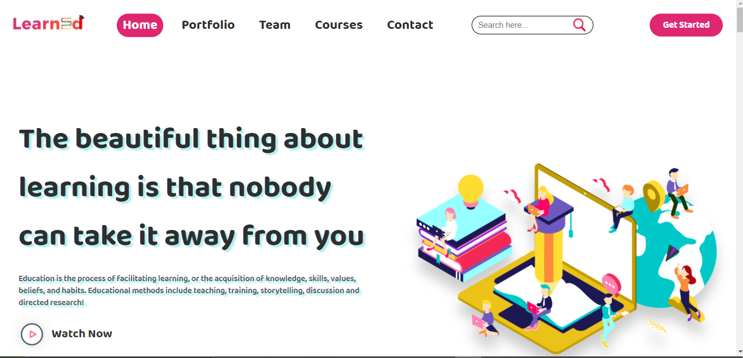

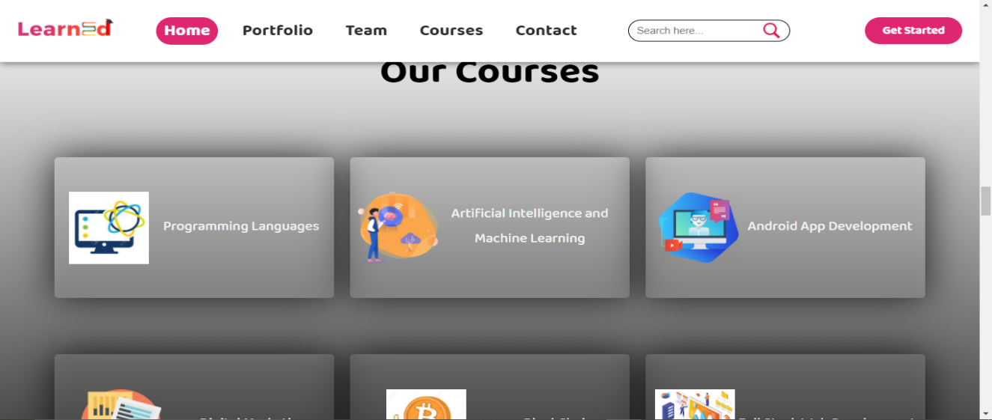

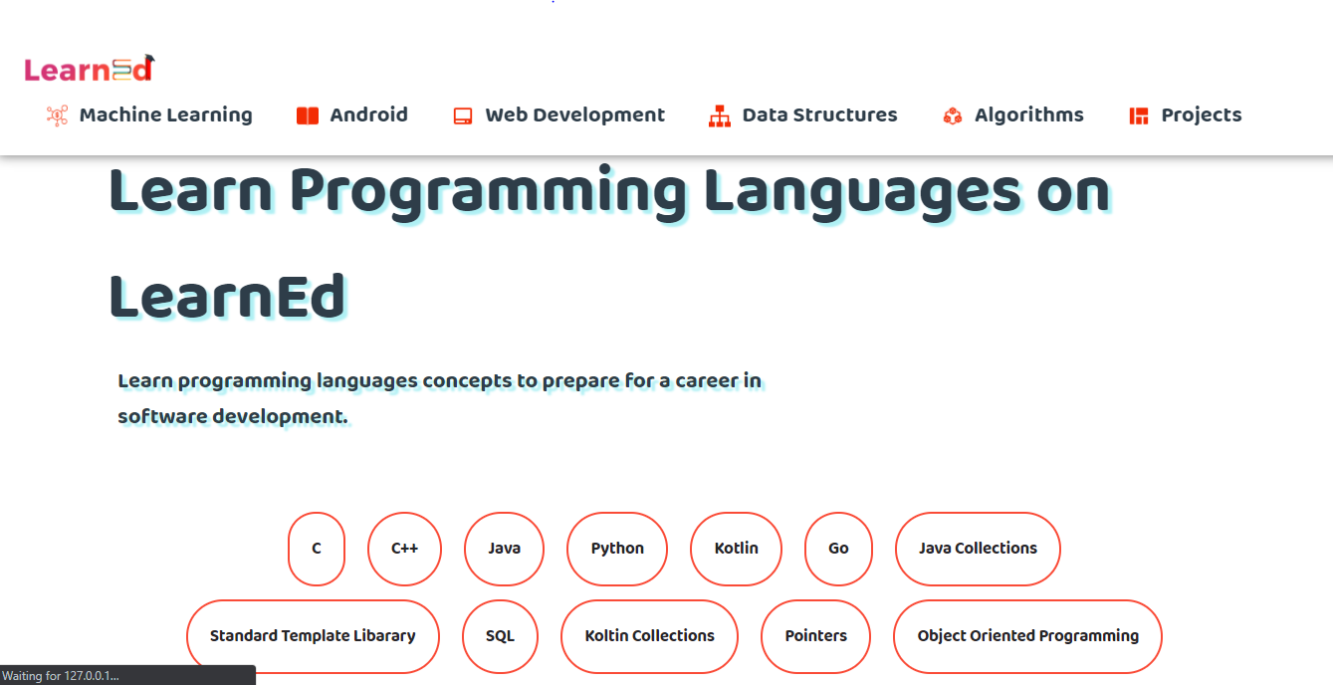

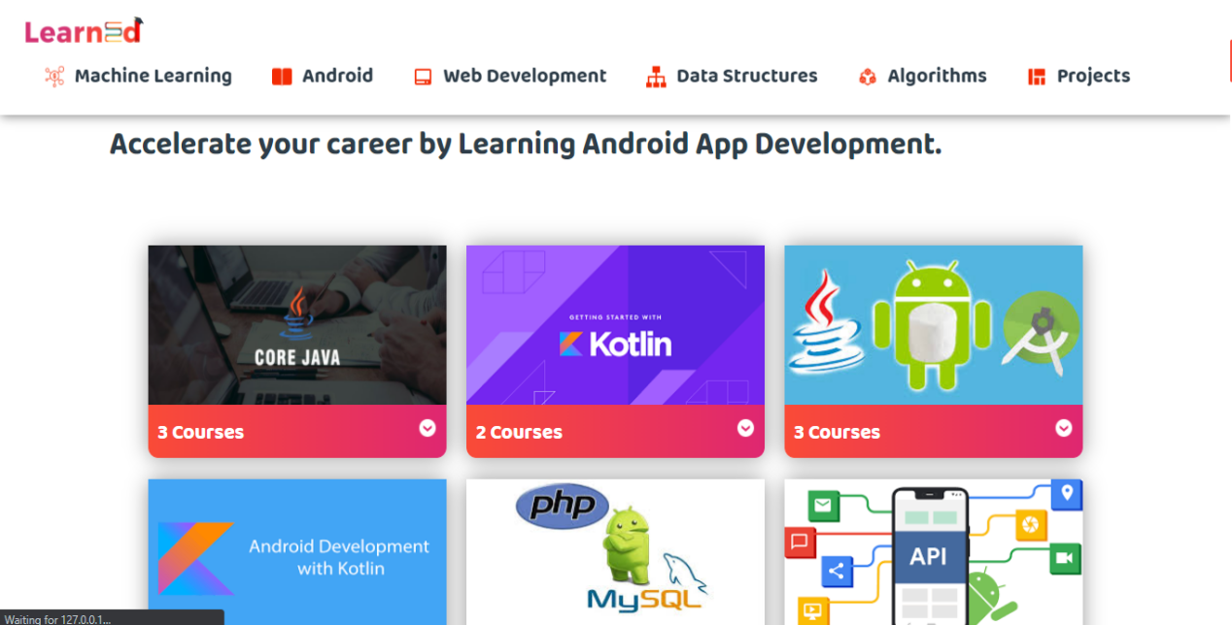

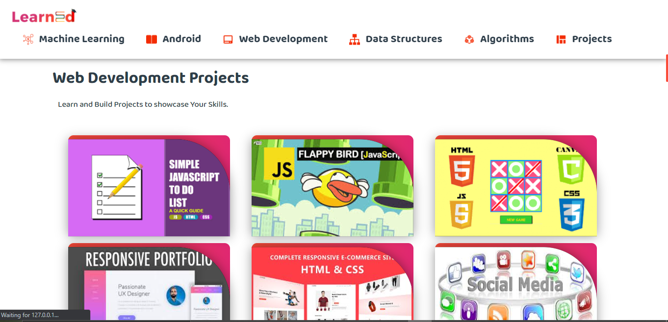

**Conclusion:**

* You are able to link the various resources in several varying formats.
* Due to its convenience and flexibility, the resources are available from anywhere and at any time.
* Everyone, who are part time students or are working full time, can take advantage of web-based learning.
* It is a very convenient and flexible option; above all, you don't have to depend on anyone for anything.
* Not only can you train yourself on a day to day basis, but also on weekends or whenever you have the free time to. There is no hard and fast rule.
* Through discussion boards and chats, you are able to interact with everyone online and also clear your doubts if any.

**References:**

* GeeksforGeeks.
* Coding Blocks.
* FreeCodecamp.org.
* Youtube.com.